PROJECT REPORT OF CO-OP Project at Industry (Module-2) ON
GameVerse
submitted in partial fulfilment of the requirements for the award of degree of

BACHELOR OF ENGINEERING
In
COMPUTER SCIENCE AND ENGINEERING

Submitted by: Supervised By:
Aayush Goel [2210991136] Dr. Rajat Takkar
Tanisha [2210990891] Assistant Professor
Keshav Garg [2210991782]
Bhavik Gaba [2210991438]



DEPARTMENT OF COMPUTER SCIENCE AND ENGINEERING

CHITKARA UNIVERSITY INSTITUTE OF ENGINEERING AND TECHNOLOGY CHITKARA UNIVERSITY, PUNJAB, INDIA

CONTENTS

S.No. | Title | Page No.
 | Acknowledgement | 4
 | Abstract | 5
1 | Introduction | 6-7
2 | Methodology | 8
3 | Tools and Technologies | 9
4 | Implementation | 10
5 | Results | 11-13
6 | Conclusion and Future Scope | 14-15
 | References | 16
 | Appendices | 17-20

DECLARATION

I hereby certify that the work which is being presented in the project report entitled “GameVerse” in partial fulfilment of requirement for the award of the degree of Bachelor of Engineering (Computer Science and Engineering) submitted in the department of Computer Science and Engineering at Chitkara University Institute of Engineering and Technology, Chitkara University, Punjab, India, is an authentic record of my own work carried out under the supervision of Dr. Rajat Takkar The matter presented in this project report has not been submitted in any other university/institute for the award of any degree.

Place: | Rajpura | Aayush Goel [2210991136]
Date: | 29/04/26 | Tanisha [2210990891]  Keshav Garg [2210991782]  Bhavik Gaba [2210991438]

This is to certify that the above statement made by the candidate is correct to the best of my knowledge and belief.

Dr. Rajat Takkar
Assistant Professor
Department of Computer Science and Engineering
Chitkara University Institute of Engineering and Technology, Chitkara University, Punjab, India

ACKNOWLEDGEMENT

We would like to express our sincere gratitude and deep appreciation to our project supervisor, Dr. Rajat Takkar, for his constant guidance, valuable suggestions, and continuous support throughout the development of this project. His insightful feedback, technical expertise, and encouragement at every stage played a crucial role in shaping the direction and successful completion of our work. We are truly thankful for his patience, motivation, and willingness to guide us whenever required.

We would also like to extend our heartfelt thanks to the Department of Computer Science and Engineering, Chitkara University Institute of Engineering and Technology, for providing us with the necessary resources, infrastructure, and a supportive academic environment to carry out this project. The facilities and opportunities provided by the department greatly contributed to the successful execution of our work.

We are grateful to all the faculty members of the department for their valuable inputs and guidance during the course of this project. Their academic support and knowledge sharing helped us in overcoming various challenges and improving our understanding of real-time systems and software development practices.

We would also like to thank our friends and peers for their encouragement, suggestions, and constructive feedback throughout the project development process. Their support helped us stay motivated and improve our work continuously.

ABSTRACT
GameVerse is a centralized, real-time multiplayer gaming platform developed to enhance user engagement in organizational and educational environments. In recent years, digital interaction has become an essential part of collaborative activities; however, most existing systems rely heavily on repetitive and limited formats such as quiz-based games. These traditional approaches often fail to sustain user interest over time, leading to decreased participation, reduced excitement, and limited overall effectiveness of engagement-driven activities.
To address these challenges, the GameVerse platform introduces a unified and scalable solution that integrates multiple interactive games within a single system. The platform is designed to support both online and offline modes, allowing users to seamlessly join, create, and participate in gaming sessions. By incorporating a room-based architecture, it enables structured multiplayer interactions where hosts can control and manage gameplay efficiently.
The system is built using modern technologies, including ASP.NET Core for backend development, Angular for frontend design, SQL databases for reliable data storage, and SignalR for real-time communication. These technologies work together to ensure instant updates, low latency, and synchronized gameplay across all connected users. The integration of SignalR plays a crucial role in maintaining live communication for bidding systems, chat functionality, and game events without requiring page refreshes.
A key focus of the platform is to ensure fairness and consistency in gameplay. This is achieved through robust validation mechanisms that prevent duplicate actions, enforce game rules, and maintain synchronization among players. Additionally, host-controlled features allow better management of game sessions, ensuring a structured and organized experience for all participants.
GameVerse also emphasizes scalability and cost-efficiency. The system is designed using a client-server architecture and is deployed using containerization technologies such as Docker, making it easy to scale with increasing user demand while keeping operational costs minimal. The modular design further allows the addition of new games and features without affecting the existing system.
Overall, the project demonstrates how real-time systems can be effectively designed and implemented to create engaging, interactive, and reliable multiplayer experiences. GameVerse not only enhances user participation but also provides a flexible and extensible platform that can be adapted for various organizational and educational use cases.

Introduction

Overview
In today’s rapidly evolving digital era, interactive technologies have significantly transformed the way individuals communicate, collaborate, and engage in activities. Multiplayer gaming and interactive engagement platforms have gained substantial importance in both organizational and educational environments. These platforms are widely used for team- building exercises, student engagement, corporate events, and informal learning experiences. They provide an effective way to enhance participation, improve collaboration, and create a dynamic environment for users.

However, despite the growing popularity of such platforms, many existing systems suffer from critical limitations. Most of the currently available solutions rely heavily on repetitive quiz-based formats or single-game environments. While these approaches may initially attract users, they tend to become monotonous over time, resulting in decreased interest and reduced user participation. Additionally, many platforms lack the flexibility to support multiple types of games within a single system, limiting their usability and long-term effectiveness.

Another major issue is the lack of efficient real-time interaction. Many platforms experience delays, lag, or synchronization problems, which negatively impact the overall gaming experience. In multiplayer environments, even minor delays can disrupt gameplay, reduce fairness, and frustrate users. Furthermore, existing systems often do not provide sufficient control to hosts or administrators, making it difficult to manage game sessions effectively.

To overcome these challenges, the GameVerse platform has been developed as a centralized, real-time multiplayer gaming system. It integrates multiple interactive games into a single platform, allowing users to seamlessly switch between different gaming experiences. The system is designed to provide smooth performance, real-time communication, and structured gameplay through a room-based architecture. By combining modern technologies and efficient system design, GameVerse aims to deliver a more engaging, reliable, and scalable solution for interactive gaming and participation.

Problem Statement
Despite the availability of various online gaming and engagement platforms, several challenges persist that limit their effectiveness in real-world applications. One of the primary issues is the lack of diversity in gaming options. Most platforms are restricted to a single type of game or rely on repetitive formats such as quizzes, which eventually reduce user interest and engagement.

Another significant problem is poor real-time performance. Many systems fail to handle real- time interactions efficiently, leading to delays, lag, and inconsistent updates. This affects the overall user experience, particularly in multiplayer environments where synchronization between players is critical.

Limited host control is also a major concern. In many existing platforms, hosts or administrators do not have sufficient tools to manage gameplay, control participants, or ensure smooth execution of events. This results in unstructured sessions and reduced effectiveness of the platform.

Synchronization issues further complicate the gaming experience. Inaccurate or delayed updates can lead to unfair gameplay, confusion among participants, and disruption of game flow. Ensuring consistency across all users in real time remains a challenge for many systems. Additionally, the repetitive nature of engagement methods used in traditional platforms leads to decreased excitement and participation over time. Users often lose interest when exposed to the same type of activity repeatedly, highlighting the need for a more dynamic and versatile solution.

Therefore, there is a clear need for a centralized, scalable, and real-time gaming platform that can overcome these limitations by offering multiple game options, efficient communication, better control mechanisms, and a more engaging user experience.

Objective
The primary objective of the GameVerse project is to design and develop a centralized platform that enhances user engagement through interactive and real-time multiplayer gaming. The system aims to address the shortcomings of existing platforms by providing a more versatile, efficient, and user-friendly solution.

One of the key objectives is to develop a unified platform that supports multiple games within a single system. This ensures variety and prevents monotony, thereby maintaining user interest over extended periods. The platform is designed to allow seamless navigation between different games, providing a smooth and consistent user experience.
Another important objective is to enable real-time interaction among users. By integrating technologies such as SignalR, the system ensures instant communication and updates, allowing players to interact without delays. This enhances the overall gaming experience and ensures synchronization across all participants.

Providing host-controlled gameplay is also a critical objective of the project. The platform equips hosts with the necessary tools to manage game sessions, control participants, and maintain order during gameplay. This results in a more structured and organized environment. Ensuring fairness and synchronization is another major goal. The system incorporates validation mechanisms to prevent duplicate actions, enforce rules, and maintain consistency among players. This helps create a fair and reliable gaming experience.

Finally, the project aims to build a scalable and cost-efficient solution. By using modern technologies and deployment strategies such as containerization, the system is designed to handle increasing numbers of users without compromising performance. At the same time, it minimizes operational costs, making it suitable for widespread adoption in both organizations and educational institutions.

Methodology

Development Approach
The GameVerse platform is developed using an iterative and modular approach. Requirements were first gathered by analyzing real-world gaming scenarios in educational and organizational settings. Based on these requirements, the system was designed, developed, and tested in phases to ensure smooth performance and flexibility.

System Design
A room-based architecture is implemented where users can create or join rooms to play games. Each room acts as an independent session, ensuring smooth multiplayer interaction. The system is designed to be user-friendly, scalable, and efficient.

Implementation
The frontend is built using Angular components, while the backend handles APIs and game logic. SignalR is integrated to provide real-time updates for gameplay and chat. All modules are connected to ensure smooth interaction.

Testing and Deployment
The system is tested for functionality, performance, and real-time synchronization. It is deployed using Docker, making it scalable and cost-efficient.

System Architecture
The system follows a client-server architecture.
    - The frontend is developed using Angular for a dynamic user interface.
    - The backend is built using ASP.NET Core to handle game logic and data processing.
    - A SQL database is used to store user and game data.
    - SignalR enables real-time communication for instant updates.

Modules
The system follows a client-server architecture.
    - User Management (login/signup)
    - Room Management (create/join rooms)
    - Game Modules (Sarkaar, Imposter, Tambola)
    - Real-time Communication (chat and updates)
    - Validation Module (ensures fairness and synchronization)

Tools & Technologies

The GameVerse platform is developed using modern technologies to ensure performance, scalability, and real-time interaction.
The system follows a client-server architecture where the Angular frontend communicates with the ASP.NET Core backend through APIs, while SignalR enables real-time bidirectional communication.
- Frontend: Angular is used to build a dynamic single-page application (SPA) with reusable components and fast rendering.
- Backend: ASP.NET Core is used to manage server-side logic, APIs, and game processing with high performance and security.
- Database: SQL database with Entity Framework is used for storing user data, game states, and chat messages. The database is designed using relational models to maintain consistency and avoid redundancy.
- Real-Time Communication: SignalR enables instant updates using WebSocket-based communication, ensuring synchronized gameplay without delays.
- Deployment: Docker is used for containerization, making the system scalable, portable, and cost-efficient.
Basic validation and secure API handling are implemented to ensure data integrity and prevent unauthorized actions.

Implementation
The implementation of the GameVerse platform is carried out in a systematic manner by integrating frontend, backend, database, and real-time communication technologies to ensure smooth and efficient performance.
The frontend of the application is developed using Angular, which enables the creation of a dynamic and responsive user interface. Various components are designed for different functionalities such as user authentication (login/signup), dashboard, room creation and joining, and individual game interfaces. Angular’s component-based architecture allows better code organization, reusability, and faster rendering of the user interface.
The backend is developed using ASP.NET Core, which is responsible for handling all server-side operations. It manages user authentication, game logic, room management, and communication between different modules. RESTful APIs are implemented to facilitate seamless interaction between the frontend and backend. The backend also ensures secure handling of requests and efficient processing of game-related data.
A SQL database is used to store essential data such as user details, room information, game states, scores, and chat messages. Entity Framework is used as an ORM (Object Relational Mapping) tool to simplify database interactions and ensure data consistency. Proper data handling techniques are implemented to maintain accuracy and reliability.
SignalR is integrated into the system to enable real-time communication. It allows instant updates for game actions, chat messages, and events without requiring page reloads. This ensures that all players remain synchronized during gameplay, which is essential for maintaining fairness and a smooth user experience.
The platform is designed using a room-based architecture, where users can create or join rooms to participate in games. Each room acts as an independent session, allowing multiple users to interact simultaneously. Hosts are provided with control features to manage participants and control the flow of the game.
Separate modules are implemented for different games such as Sarkaar, Imposter, and Tambola. Each game has its own set of rules, logic, and user interface, making the platform versatile and engaging. The modular design also allows easy addition of new games in the future.
Validation mechanisms are incorporated throughout the system to prevent duplicate actions, enforce game rules, and ensure fair gameplay. These validations help maintain consistency across all users and avoid errors during real-time interaction.
The system is thoroughly tested for functionality, performance, and synchronization. Testing ensures that the platform can handle multiple users efficiently and provide a seamless gaming experience. Finally, the application is deployed using Docker, which provides a scalable and cost- effective deployment solution.

Results

The development and implementation of the GameVerse platform resulted in several important findings and outcomes. The system was successfully tested in a real-time environment and demonstrated significant improvements over traditional gaming and engagement platforms.

Key Outcomes
    - Successfully developed a centralized multiplayer gaming platform integrating multiple games in one system
    - Enabled seamless switching between games without exiting the platform
    - Created a user-friendly and interactive interface for better usability
    - Achieved smooth integration of frontend, backend, and real-time components

Real-Time Performance
    - Implemented real-time communication using SignalR
    - Achieved instant updates for:
      - Game events
      - Chat messages
      - Bidding actions
    - Ensured low latency and minimal delay during gameplay
    - Maintained synchronization among all connected users

Improvement in User Engagement
    - Replaced repetitive quiz-based systems with interactive multiplayer games
    - Increased user participation and interest levels
    - Provided variety of games (Sarkaar, Imposter, Tambola)
    - Created a more engaging and dynamic environment
    - Suitable for:
      - Educational institutions
      - Organizational events
      - Team-building activities

Host Control and Game Management
    - Enabled host-controlled gameplay
    - Provided features for:
      - Room creation and management
      - Player control and monitoring
      - Game start/stop functionality
    - Ensured structured and organized gaming sessions
    - Improved overall event management efficiency

Fairness and Validation
    - Implemented validation mechanisms to ensure fair gameplay
    - Prevented:
      - Duplicate actions
      - Invalid inputs
      - Rule violations
    - Maintained consistency across all users
    - Ensured equal participation opportunities

System Performance and Scalability
    - System supports multiple users simultaneously
    - Handles multiple game rooms efficiently
    - Maintains stable performance under load
    - Designed to be scalable for future expansion
    - Can easily support addition of new games and features

Cost Efficiency and Deployment
    - Deployed using Docker containerization
    - Reduced need for expensive infrastructure
    - Ensured easy deployment and maintenance
    - Provides a cost-effective solution for institutions

Technical Achievements
    - Successful integration of:
      - Angular (frontend)
      - ASP.NET Core (backend)
      - SQL Database (data storage)
      - SignalR (real-time communication)
    - Achieved modular architecture for easy updates
    - Ensured secure and efficient data handling

Overall Impact
    - Improved user interaction and collaboration
    - Provided a modern alternative to traditional engagement methods
    - Delivered a reliable and scalable gaming solution
    - Demonstrated practical implementation of real-time systems

Comparative Improvement (Before vs After GameVerse)
Before GameVerse:
    - Limited to single or quiz-based games
    - Low user engagement
    - Poor real-time interaction
    - Lack of host control
    - Synchronization issues After GameVerse:
    - Multiple games in one platform
    - High user engagement
    - Real-time synchronized gameplay
    - Full host control
    - Smooth and reliable performance

Conclusion & Future Scope

Conclusion
The GameVerse project successfully achieves its objective of developing a centralized, real- time multiplayer gaming platform that enhances user engagement in both organizational and educational environments. The system effectively addresses the limitations of traditional engagement methods, which are often restricted to repetitive and less interactive formats such as quiz-based activities.

Through the integration of modern technologies such as Angular, ASP.NET Core, SQL Database, and SignalR, the platform provides a smooth, responsive, and real-time interactive experience. The implementation of SignalR ensures instant communication between users, enabling synchronized gameplay and eliminating delays that are common in many existing systems.

One of the major strengths of the GameVerse platform is its ability to host multiple games within a single system. This not only increases variety but also keeps users engaged for longer durations. The room-based architecture further enhances the system by allowing multiple game sessions to run independently, ensuring flexibility and scalability.
The project also emphasizes fairness and structured gameplay. Validation mechanisms are implemented to prevent duplicate actions and enforce rules, ensuring that all users have a consistent and fair gaming experience. Additionally, host-controlled features allow better management of game sessions, making the platform suitable for organized events and team- based activities.

From a technical perspective, the project demonstrates the effective use of client-server architecture and real-time communication technologies. The modular design of the system ensures easy maintenance and allows future enhancements without affecting existing functionalities. Deployment using Docker further makes the system scalable, portable, and cost-efficient.

Overall, the GameVerse platform provides a reliable, efficient, and scalable solution for real- time multiplayer gaming. It significantly improves user interaction, engagement, and collaboration, making it a valuable tool for modern digital environments.

Future Scope
Although the GameVerse platform has successfully achieved its current objectives, there are several opportunities for further enhancement and expansion. The system has been designed with scalability and flexibility in mind, allowing future improvements to be integrated easily.

One of the primary areas of future development is the addition of more interactive and diverse games. Expanding the variety of games will further enhance user engagement and make the platform more versatile for different use cases.

Another important improvement is the development of a mobile application. Currently, the platform is web-based, but extending it to mobile devices (Android and iOS) will increase accessibility and allow users to participate anytime and anywhere.

The integration of Artificial Intelligence (AI) can further enhance the platform. AI can be used to create intelligent opponents, provide personalized recommendations, and analyze user behavior to improve the gaming experience. It can also help in detecting unfair practices and improving system security.

Advanced analytics and reporting features can also be added in the future. These features will allow hosts and administrators to track user performance, participation levels, and game outcomes. Such insights can be useful in educational and organizational settings for evaluating engagement.

The platform can also be enhanced by improving security features. Implementing advanced authentication methods, data encryption, and secure APIs will further strengthen the reliability and safety of the system.

Another potential improvement is the integration of cloud-based services. Migrating the platform to cloud infrastructure will enhance scalability, reliability, and performance while enabling the system to handle a larger number of users simultaneously.

References
- Angular Official Documentation – Frontend development and component-based architecture
- ASP.NET Core Documentation – Backend development and API implementation
- SignalR Documentation – Real-time communication and WebSocket integration
- Entity Framework Documentation – Database handling and data management
- Docker Documentation – Deployment and containerization
- Research articles and online resources on real-time multiplayer systems and game architecture

Appendices

Appendix A: User Interface Screens
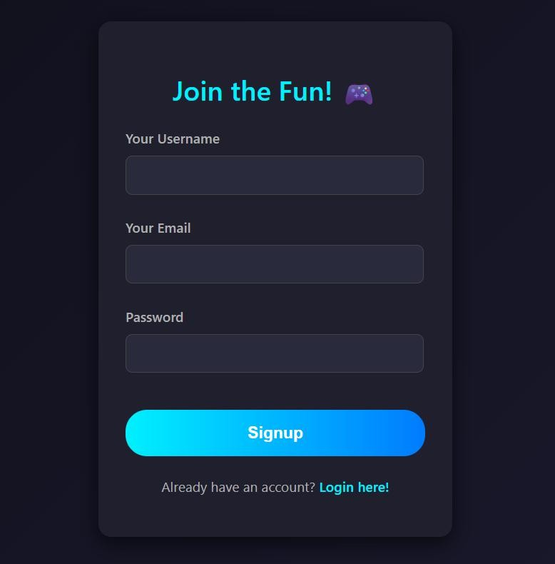
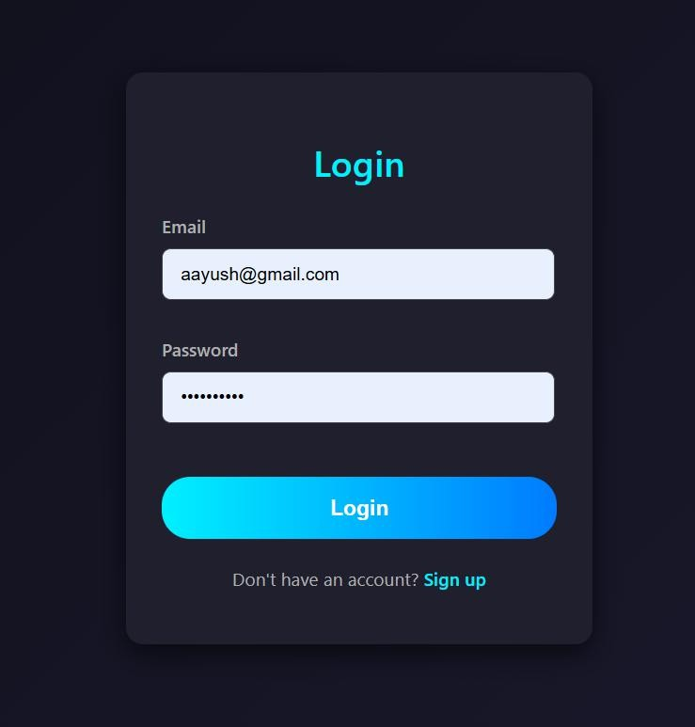
Figure A.1: Login / Signup Page

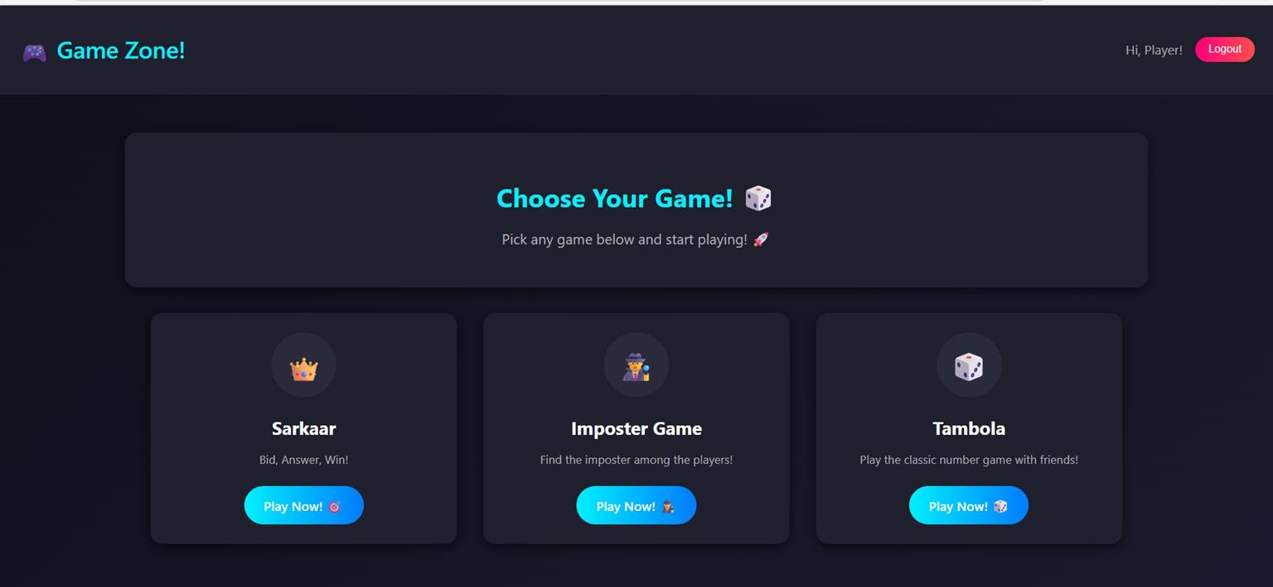
Figure A.2: Home Dashboard

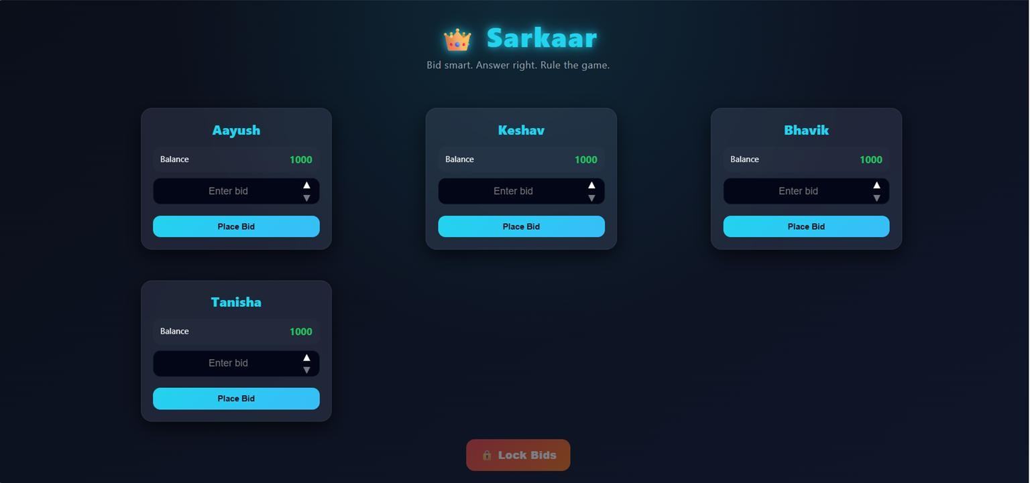
Figure A.3: Sarkaar Game Interface

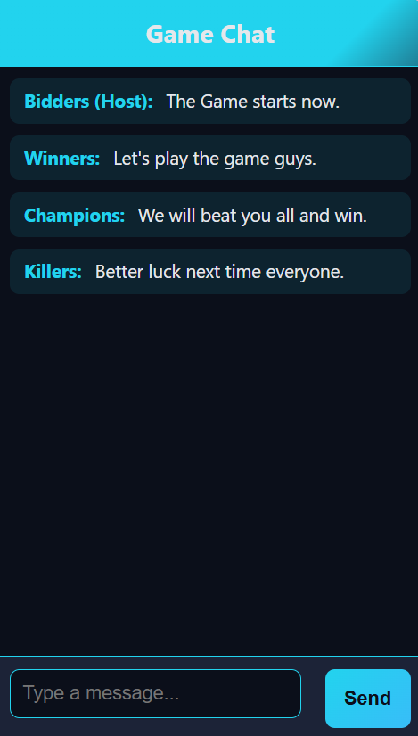
Figure A.4: Game Chat Interface

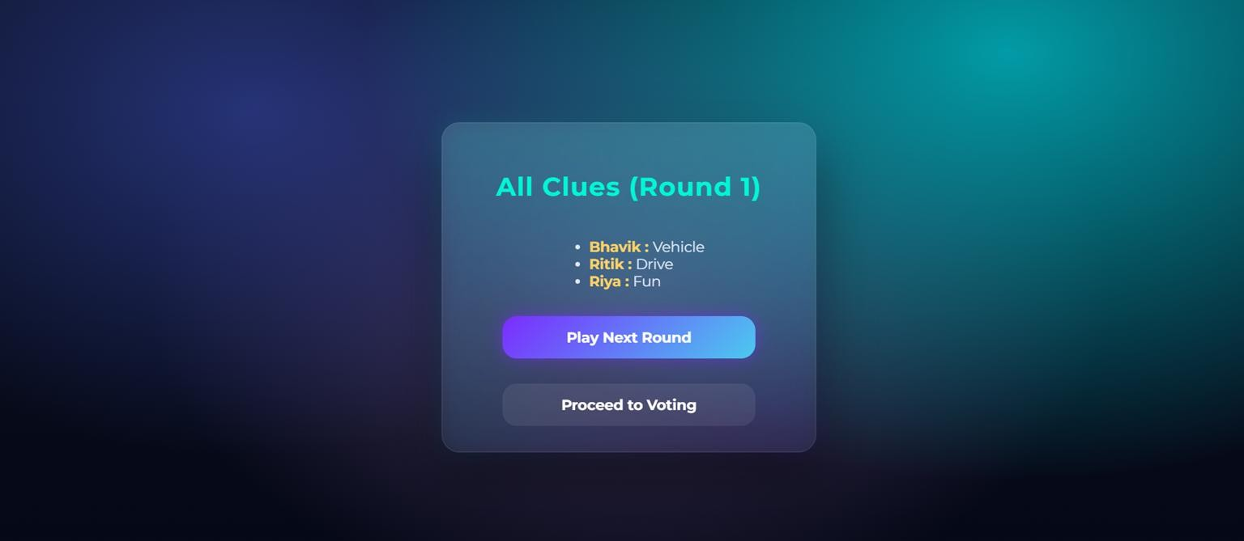
Figure A.5: Imposter Game Screen

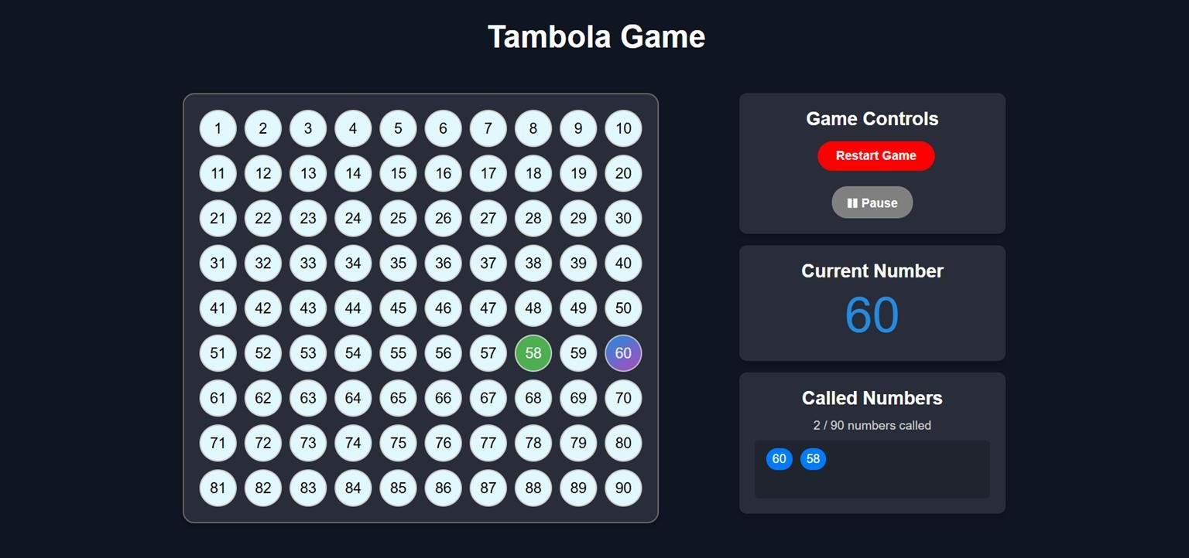
Figure A.6: Tambola Game Screen

